THE SWATH CTV – FINALLY COMING OF AGE

J.Kecsmar, Ad Hoc Marine Designs Ltd., UK
J. William McFann, Island Engineering Inc., USA
Capt. David Low, Maritime Craft Service (Clyde) Ltd., UK

ABSTRACT
Conventional CTVs have been restrained by legislation, to be below 24m Loadline rules to save costs and further hindered by having to be below 12 passengers otherwise being faced with “big ship” rules. However, whilst these challenges are now being overcome with the new HSC-OSC rule to allow for up to 36 passengers the most difficult challenge remains, that of small boats going out in increasing sea state. All vessels that are in the sub 24m and up to 30-40m exhibit similar natural periods of motion and consequently have similar seakeeping characteristics. The round three windfarms are exposed to Hs=3.0m and existing conventional vessels are not suitable in terms of seakeeping for low motions and the ability to safely transfer technicians at the tower in the increasing sea state, at least not without the aid of a highly damped transfer system. Why focus on the damped transfer gangways alone when the most obvious solution is to have the whole vessel highly damped. If the vessel is highly damped to begin with seakeeping and transfers become significantly improved and safer. The 26m Typhoon Class Swath is such a vessel and has proven to outperform expectations with transfers in sea states beyond any conventional vessel of the same size. Has the once considered “black sheep of the family” type of vessel, a Swath, finally come of age?

NOMENCLATURE

Hs | significant wave height (m)
a | hull added mass and inertia coefficient
b | hull damping coefficient
c | hull restoring force coefficient
k_{xx, yy} | radius of gyration (m)
g | gravitational acceleration 9.81ms⁻²
GM_{T} | transverse metacentric height (m)
GM_{L} | longitudinal metacentric height (m)
ρ | density of fluid (kg.m^{-s})
∆ | displacement ( tonne)
A_{W} | waterplane area (m)
ω | wave frequency (rad)
ω_{e} | encounter frequency (rad)
ϕ | heading
V_{s} | vessel speed (ms⁻¹)
a_{cg} | vertical acceleration (ms⁻²)
ζ | amplitude (m)
T | period (s)

1. INTRODUCTION

The UK windfarm industry has been growing steadily over the past decade. The first large-scale offshore wind farm in the UK, North Hoyle, was commissioned in December 2003, and the second, Scroby Sands, one year later in December 2004, followed by the UK’s then-largest offshore wind farm, the 90MW Kentish Flats in

2005. This spawned the current range of workboats which are all catamaran vessels of the order of 12-24m in length (Lwl) with a passenger capacity of up to a maximum of 12 – now termed technicians or industrial personnel. Access to the turbine tower is from shore via these small workboats which run out to the towers and these technicians step across the bow onto a ladder. They operate in the inshore side of the farms of what is termed “round one” and run in generally benign sea conditions but in winter months and when the weather is inclement often have to work in sea conditions of up to 1.5m significant wave height. These first generation catamarans fulfilled the role very well.

However as the windfarms become numerous the role of the catamaran began to evolve from a simple point A to B vessel into a multitasking vessel. With requirements of carrying spare generators on the deck and requiring heavy duty cranes for lifting heavy weights up to the towers etc. As time progressed the round one farms also evolved into round two and subsequently the larger powering generating turbines began the slow migration from inshore to offshore. This is where the technical challenges slowly began to test the limits of the existing designs on two fronts, the first is the seakeeping of the vessel which leads to fatigue of the crew and technicians and secondly the safe transfer of the technicians in the increasing sea state. This paper focuses upon the later aspect whilst noting it is inextricably linked to the former, that of seakeeping.

2. TRANSFER OF TECHNICIANS

A typical transfer of the technicians is shown in Fig.1. The vessel pushes up against two vertical poles either side of the ladder on the turbine tower with sufficient force to hold the bow of the vessel onto the tower, which then allows the technician to step from the foredeck of the vessel onto the tower’s ladder.

It can be seen that the transfer shown in Fig.1 is in relatively clam conditions. With such a slight sea state the transfer is easy and conducted in safety. As the number of farms increase and the further offshore they are sited brings with it an increase in the sea states these CTVs are exposed to, not just during the hard winter months but annually. As such it becomes increasingly challenging for the Master of the vessel to perform this operation safely. With the bow of the vessel rising and falling as much as 2.0-3.0m in inclement weather it is clear that the transfer of technicians requires a method or system that is controlled and safe. A method that is less hit and miss and guess work, but one that provides a degree of control and assurance for both the Masters, and the technician that is stepping across from the heaving bow to the turbine ladder.

2.1 Methods of Transfer

An example is shown in Fig.2, which uses a heave compensated gangway. Whilst these types of transfer gangway assist in extending the sea state limits for safe transfers, it can be seen that the whole of foredeck is now taken up by the gangway system. This is a departure from the now multi versatile CTVs where a large open foredeck is the norm.

As such it is hard to image how such units could be used on anything other than a much larger vessel. Since the now cluttered foredeck with cranes and containers etc limits the vessel with such a gangway from the now common multitasking vessel to that of a pure technicians carrying CTV.

Alternative heave compensated gangways have been successfully exploited on previously designed crew transfer vessels in the past. An example is shown on the FBM Designed and built Swath in 1997 [1] that uses a simple single cylinder to damp out vertical heave motions, shown in Fig.3. The gangway, or brow, is located on the side of the vessel for beam to beam passenger transfer from ship to ship. Being located on the beam simplifies the mechanism considerably, since the only motion to account for as the vessel pitches or heaves or rolls, the displacement that is experienced at the side, is purely vertical.

A modified and updated version was designed by Ad Hoc Marine Designs in 2008 for use on the foredeck of another Swath shown in Fig.4. Being on the foredeck increased the complexity of the system as well as the cost. However it was still a compact unit.

The gangways, or brows, shown in Fig’s.3 and 4 have been successful principally owing to the benign motions of the vessel it is sited on – this is the principal reason for such small compact units compared to those on offer in today’s market. Had these systems been employed on conventional multihulls, it is highly likely that major modifications would have been required. This was most certainly true in the case of the Autobrow, designed by Ad Hoc Marine deigns as part of the Carbon Trust competition for methods of safer transfers. The design was one of the 13 eventual winners, as shown in Fig. 5.

The size of the unit is clearly much larger and the hydraulics required resulted with much higher power requirements. The reasons for the difference between the two, one on a Swath and the other on a catamaran are simple naval architecture and hydrodynamics of the vessels they are sited on. The vessels shown in Fig.1 and 2 are typical CTVs in the 20-24m size. These vessels all exhibit very similar natural periods of motion despite their varying hull shapes; the displacement and waterplane area ratios are very similar.

2.2 Basic Requirements

Taking the typical 20-24m catamaran as an example, what would be a typical pitch period and heave period? For this vessel, empirical evidence (and from the author’s own database from sea trials of previous vessels) suggests approximately 2.5 seconds for both pitch and heave. Given this the range of motions and this forces that any gangway or brow is required to compensate for can be calculated. For the catamaran CTV the tangential force when pitching is calculated as 1.2kN the force normal to this as 7.7kN and the vertical heave as 25.6kN, assuming a range of motion of 2.50m or ± 1.25m. A Swath of the same size has a pitch period of 6 seconds and heave period of 5 seconds. Assuming everything else remains the same the tangential force reduces to 0.2kN (83% less) normal to this of 1.3kN (83% less) and the heave to 13.7kN (46% less). It is very obvious that the change in natural periods of the vessel has a significant effect on the forces experienced and hence the power requirements for the damping system that is utilised. And this leads to large cumbersome units like those shown in Fig.2 and Fig.5.

The reason for the big differences in natural periods, and hence forces, is purely hydrodynamic. All objects have a natural frequency of vibration, and this is true of any object be it car or boat. If the natural frequency coincides with the same encounter frequency of each wave this creates the very unpleasant motions called resonance. Therefore to understand the effects of waves on a boat is to understand the natural frequency and what influences them. The period of motion is given by the following expression:

a.d²θ + b.dθ + c.θ = Forcing Moment
dt² dt

Where a, b, and c are hull coefficients. The forcing moment is the wave. When this is set to zero, it provides the ability to find the natural frequency of motion.

Rolling Period T = 2π.k_{xx}
√(g.GM_{T})

Pitching Period T = 2π.k_{yy}
√(g.GM_{L})

Heaving Period T = 2π. √(ρ.∆)
(g.A_{W})

What is very obvious to a naval architect is that all three natural periods of motion are influenced by the hull shape. The periods of: roll - GM_{T}, pitching - GM_{L} and in heave are all dictated by the waterplane area A_{W}. Also what we can see is that to increase the natural periods we must either i) increase the displacement or ii) reduce the waterplane area or a combination of the two.

All small vessels beit a monohull or catamaran in the 20-40m range have natural periods of roll, pitch and heave in the order of 2.5 to 4.0 seconds. Thus, the displacement and the size of the waterplane area result in these short periods of motion. This brings us to the influence on waves and their encounter.

The expression that defines how this speed and distance between wave crests affects the encounter period is given by:
$$ω_{e}=ω\left[1+\frac{ωV_{s}}{g}cosφ\right]$$

From this expression we can calculate the frequency of encounter knowing basic characteristics of a wave, such as its: period, length and speed, as well as the heading, ϕ, and speed of the vessel, V_{s}. Thus for a given wave we can plot how the wave can have an influence on the vessel when running at varying speeds and direction. Typical significant wave height (Hs) values in the North Sea location that are in the round three zone are shown and with corresponding wave heights shown in Fig.6 [2].

We can see that in the summer months the dominate wave heights are in the 1.0-1.50m, but in the winter months 2.0-2.5m dominate. This has been previously highlighted for farms that are up to 300km offshore, with Hs=3.0 being a concern. If we now use this wave data we can plot a speed of vessel versus encounter period, and using a nominal Hs=2.0m and assuming head seas, as shown in Fig.7. Also shown shaded is the typical natural frequency of vessels in the 10-40m range, that of 2.5 -4.0 seconds. What is very obvious is that for a wave of Hs=2.0m for speeds under 30knots the vessel shall have encounter periods matching the vessel natural periods of motion. This means resonance and uncomfortable motions. The only solution is to i) reduce speed to reduce the accelerations being experienced or ii) power through past 30knots.

The accelerations that are experienced owing to resonance of the vessel in the sea state can be calculated knowing that a_{cg} = ω_{e}².ζ, which means the encounter period squared times the amplitude of the motion. The goal being to reduce the encounter period and the amplitude of the resonance as this leads to lower vertical accelerations. So going faster is a solution, but the vertical accelerations can eventually become unacceptable owing to the high encounter frequency. To put this into a bit more context, the period of motion is given by the simple equation:

T = 2π/ω

So, if the encounter period is 10 seconds, this gives ω_{e} as 0.628 radians. If the period is halved to 5 seconds, it is 1.257 radians and halved again to 2.5 seconds gives 2.513 radians. It becomes clear that for a constant wave height, if ω_{e}² changes the accelerations change too. So with T = 10 seconds 0.628² = 0.39, whereas 2.513² = 6.32, which is more than 16 times greater, i.e. higher accelerations. Clearly demonstrating the link between encounter frequency and accelerations experienced. Thus, increasing the encounter period for a given constant wave amplitude, the resulting change in motions lead to lower vertical accelerations. This is easily achieved by simple manipulation of a Swath hull form, but for a conventional vessel there is very little room for manoeuvring in terms of how much can really be changed.

Since the vessel must go over 30knots to move out of the resonance zone of encounters which inevitably means larger engines and larger jets. This adds to the lightship weight, not ideal for the small craft as this increases capital cost, and consequently making the vessel’s daily charter rate higher! It also decreases the length-displacement ratio (LD). There is very clear evidence of decreasing LD ratio increasing accelerations. In other words, the existing CTVs of small catamaran hull configuration are not ideally suited for the round three farms, based upon the simple hydrodynamics of their hull forms.

3 CHANGE OF HULL FORM

When the CTV is running from the port to the tower, it is assumed to be running at its service speed; in this case in the 25-30knots region. As can be seen in Fig.7, with a Hs=2.0m head sea the beginning of the resonance and zone of uncomfortable motions is already set at these speeds; ensuring an encounter outside the 2.5-4.0 seconds is required. A typical fast ferry catamaran that is 30m, like that of RedJet 3, that runs between Cowes on the Isle of Wight to Southampton has a roll period of 2.7 seconds. The LD ratio of this catamaran hull form is suitable for fast ferries and much higher than that of a CTV. However if the vessel were to be made to carrying more payload for the outer farms and remain the same size thereby lowering the LD ratio of the hull form considerably, the motions would not be improved, since the WPA would increase to provide the more buoyant hulls required, thus increasing the GM_{T} and hence remaining a short period of roll. Changing this roll period is extremely difficult with a conventional hull form, as the resulting displacement required, keeping all other hull attributes the same, requires a change from 90 tonne to 580 tonnes!

3.1 Appendage Options

Other than major changes in the hull form, would adding appendages help the case to continue with a catamaran hull form? Appendages are the “b” coefficient in the motions given in 2.2. Appendages such as passive bilge keels or T-foils are common solutions for vessels on exposed routes. Independent research [3] shows that passive appendages have little influence on the motions, shown in Fig.8. The issue is compounded when considering the CTV has a low LD ratio hull form, unlike the higher LD hull form fast ferry types. These low LD ratio hull forms are characterised by a much stiffer WPA inertia and consequently requires a much larger restoring force to overcome the high inertial WPA stiffness.

The use of active T-foils has become a common feature on fast ferries where these systems have been shown to improve motions and reduce accelerations. However these are on hull forms with a much higher LD ratio where the restoring forces required pro-rata are much less than on low LD hull forms like CTVs. This results in increasing the size of the T-foils which means heavier equipment but more importantly an increase in drag, which slows the vessel down.

So the use of passive appendages will not provide sufficient effect to counter the higher motions that shall be experienced on these exposed routes for these short and heavy catamaran hull forms used by CTVs. Active appendages will not have much influence on the low LD hull forms but are better than passive. However, just not enough for such exposed routes owing to the forces required to compensate, renders such systems, like the gangways, large and heavy.

The evidence from the simple review is clear that a standard catamaran type hull form is not ideally suited for the higher sea states and a change in the hull form is required. The vessel may well be able to perform from a purely technical point of view, in terms of speed and payload capacity, but it is hindered by its own geometric limitations that influence its own natural motions and/or appendages damping them, and thus, renders operations in higher sea states uncomfortable and hazardous for transfers onto the towers.

What is also clear from the evidence of using heave compensated gangways on different vessel types, is that it points to the most obvious solution. The heave compensated gangways used on Swath vessels have been small compact and very successful. The required reduction in vertical displacement may be similar to that of a conventional vessel, in a similar sea state, but the reduction in forces and thus accelerations makes controlling such gangways significantly easier. Therefore if a heave compensated gangway works easily owing to the benign long period motions of a Swath, why not make the whole vessel “heave compensated” as such? With a hull form that has a roll period of 9 seconds, as MCS Swath 1 does, this becomes the “gangway”. In other words the heave compensated gangway is the hull itself. A Swath hull form is therefore the most obvious hull form selection to minimise the accelerations and thus minimise the crew and technicians fatigue during long exposed transits and more importantly when transferring technicians on the tower.

In addition to the longer periods of motion, the stiffness of the waterplane area is much lower than a conventional CTV, which means the ability to provide damping via passive control surfaces is greatly improved. Small appendages such as bilge keels or fixed fins, can provide a significant reduction in amplitudes, which is not possible on conventional hull forms.

3.2 Powering Requirements

There are two arguments, myths even, with regards to Swaths. One is that of its resistance being a very draggy hull form and the power requirements merely to achieve a medium speed are cost prohibitive. The second is that they are so weight sensitive they are unable to carry high payloads. There is some truth in this, however, a CTV has a low LD ratio, in other words, it is draggy for its length. Bearing in mind that the existing CTVs at the time of design are generally built to remain below the 24m Laodline rules, we can use this as a basis for comparison. Using three typical hull forms: i) A typ catamaran CTV hull, ii) a generic high speed Swath hull and iii) a generic slow speed Swath hull and plotted on a speed versus resistance graph Fig.9, the results are rather illuminating. Because the typical CTV catamaran hull has such a low LD ratio is has a slightly higher resistance than compared to a high speed Swath hull form. The resistance curve of a typical slow speed Swath is clearly very draggy and is where most myths stem from, with regards to power requirements.

Given the sea conditions in Fig.6 and knowing their periods referring this to the encounter v speed chart in Fig.7, above 4.0seconds would be a good start at the lower end of the speed range and 2.5 seconds at the higher speed end. What is also obvious from the chart and requirements for a Swath hull form, Fig.7 indicates the conflicting requirements that must be equally satisfied; that of slow speed encounter periods and high speed encounter periods. A typical slow speed Swath hull form is optimised using appendages and the hull form itself to create large amounts of damping and natural periods sufficiently far removed from the expected wave conditions. The amount of damping on a Swath can reduce the vertical motions to almost zero. However, as the appendages are added to increase the damping, it increases the resistance considerably. This is shown by the slow speed Swath curve in Fig.9. Such a Swath is optimised for slow speed and stationary conditions to reduce the heave amplitude to near zero. This is to ensure the natural periods of motion are sufficiently far away from the stationary wave encounter periods. As can be seen in Fig.7 when a typical 30m CTV vessel is running at its service speed the period of encounter very closely matches the natural periods of the vessel. However, this encounter period changes from that of circa 2.5 seconds at 30 knots to 6.5 seconds when stationary. Yet typical waves of Hs=2.0m in the North Sea have wave periods of circa 6.5 seconds. This means the Swath must have its natural periods of motion sufficiently far away from 6.5 seconds to avoid any resonance – unfortunately this coincides with the natural periods of the high speed Swath hull form. This is where the conflicting requirements of slow speed/stationary conflict with that of high speed; how to make a Swath hull that has its natural periods of motion suitable for high speed - to reduce drag - and also at slow speed -without causing drag.

3.3 Optimising Appendages

The solution lies in the understanding of what a low WPA actually means. A low WPA is a low restoring force which means it is easy to control with external influences. A sensitive Swath is very easily recognised merely by walking across the deck, the slight changes in trim and list can be readily felt. Ad Hoc Marine Designs were responsible for the production design naval architecture of the Lockheed Martin SLICE©, and with just one or two persons walking across the deck a very noticeable list occurred. This is where the second myth about Swaths being unable to carry large payloads comes from. A Swath hull form is designed to be sensitive; it is its raison d’etre. This is mistaken for not being able to carry loads. A Swath is a fixed draft vessel, and the payload is designed into the hull form from the outset. Its ‘sensitively’ to minor perturbations, is irrelevant in this context, as it is sensitivity to changes in the arrangement of weights alone; since the fixed trim means fixed LCG.

Thus, being very sensitive to changes in weight distribution also has the same effect with a foil or fin that creates a lift force; it can easily restore the Swath’s running attitude back to zero. If a Swath is tuned to be radically different from ocean swell encounter periods, such as the SSP Kaimalino Swath or the larger Kaiyo, it is extremely sensitive and when under way this sensitively results in a low longitudinal pitch stiffness. This gives rise to the commonly known Munk effect. These larger slow speed Swaths that have been built, make use of passive or active motion control fins both fwd and aft to ensure that any onset of pitch instability is corrected by the force from the fins provided by the passive fins or active motion control system.

What if a correctly designed motion control system could be used help to bridge the gap between slow speed requirements and that of high speed requirements. The high speed is obviously much easier, but if the fins could be larger to provide -additional control and damping than would otherwise be - and with a degree of control when stationary too - that would possibly solve the dilemma. The flaw in this argument is that fins which are lifting surfaces only work with forward speed to provide the lift. However, a motion control system that is able to provide heave compensation by actively moving the fins when stationary will have a significant effect on a sensitive Swath hull form. Couple this to additional appendages in the form of bilge keels and adding more damping to the hull shape, the combination will provide the slow speed motions that are desired.

3.4 Motion Control System

The active stabilization system installed on the Ad Hoc Designs 26 meter CTV, “MCS SWATH 1”, is the current implementation and integration of Swath active control approaches and methods first developed and documented as part of the USN Swath development efforts [4, 5]. The system originally developed and implemented by Dr.Higdon has been extended, through further development and trials over the years, to include the contouring control objective in addition to the platforming mode. The use of unreliable depth pressure sensors to determine bow immersion, as needed to support earlier implementations of the contouring control mode, has been rendered obsolete by the availability of lower-cost but highly accurate microwave radar bow height sensors. The general arrangement of a modern Swath stabilization system, and as installed on the “MCS SWATH 1” CTV is shown in Fig.10.

Underway trials of MCS SWATH 1, conducted in seas exceeding 2 meters significant wave height, demonstrated that the performance of the active stabilization system was extremely good and as expected for this vessel and control system combination. In addition to reducing RMS pitch and roll motions to very low values, the system maintained vessel attitude – trim and list – to within vary narrow limits at all times from speeds of approximately 8 knots through full ahead, Fig.11.

What is new or novel about the stabilization system installed on the “MCS SWATH 1” CTV is the addition of a new control mode, developed for use when the vessel is lying to or at slow speeds ahead up to about 3 knots. This low- and zero-speed mode has, as its control objective, the reduction of bow heave motions; motion primarily results from pitching. The benefits of this control mode are twofold; the bow vertical motions are reduced during an approach to the landing on the turbine pylon, and the passenger comfort on board is enhanced during periods when the vessel is loitering on station between assigned transfer tasks.

Unlike the control of motions and vessel attitude underway using proportional control of the fin angles to vary fin lift forces, zero-speed control is effected by the use of impulse functions. The fins are “triggered” to rapidly move between their limit positions in response to a fuzzy-logic control algorithm that times the impulses to coincide with a specific magnitude and phase angle of a pending bow height deviation or excursion. The forces that create the impulse, the integral of force over the time duration of the fin sweep, result from the viscous resistance and change in momentum of the water that the fin creates as it flips from one limit angle to the other. Because the fin has more than 75% of its total planform area to the trailing side of the fin shaft, there is a net force and impulse created, as illustrated in Fig.12.

Although the resulting impulse values are not particularly large, their effect, properly timed and applied, on the very lightly damped but also lightly forced Swath pitch motions is quite significant when in wave conditions where the resonant pitch and bow heave behavior is being excited.

In Fig.13, are results from initial trials with MCS SWATH 1 Zero-Speed Heave (ZSh) Stabilization, off Denmark coast, 17 Sept 2016. The data from two contiguous sets of measurements is presented, showing the reduction in pitch rate, and hence bow heave, resulting from the toggling of fin positions in response to the damping control algorithm.

Sea conditions and the effects of engaging the zero-speed mode are as follows:

Loitering in 1.2-1.4m Hs seas, predominantly from stern

>58% reduction in RMS pitch rate
>70% reduction in RMS pitch angle
>70% reduction in RMS bow vertical displacement

Chart units: pitch angle (deg), pitch rate (deg/s), fin angles (degrees) Note: Fins are actually toggling between plus/minus 40 degrees. The Y-axis range is trimmed for clarity.

The unique zero-speed mode is fully effective with the low stiffness of a Swath hull form. The reduction in angles and amplitude of over 70% in moderate sea condition is evidence of the effectiveness of the system coupled to a low stiffness hull form. This achieves the objective of the design brief of a system that can bridge the gap between a high speed Swath hull form with that of a slow speed Swath hull form enabling the new hull form to maintain a high speed whilst augmenting the requirements at slow and stationary speeds.

4 IN-SERVICE OPERTATIONAL EXPERIENCE

The following account is based upon the experience and testimony of the Capt of the Swath vessel MCS SWATH 1, operated by Maritime Craft Services (Clyde) Ltd (MCS). MCS has been operating the vessel since September 2016 at various locations in the North Sea.

4.1 Motions

The first thing to notice on MCS SWATH 1 is the lack of motion. It is absolutely astonishing when the vessel can maintain its full crusing speed in seas exceeding Hs= 2.0m in any direction without any concerns for the safety of the vessel or the comfort of the passengers / technicians. What this means is when operating the vessel during transit the technician are free to move around the vessel can relax and enjoy hot refreshments without fear of spilling hot coffee on themselves. The technicians now arrive at their place of work relaxed and ready to start.

4.2 Pushing onto the Tower

The next benefit of the Swath hull form comes in to play on site. Once the procedure of pushing onto the tower begins there is no movement at the bow whatsoever, even up to and beyond Hs=2.0m. This clearly demonstrates a much safer and controlled environment for allowing the safe transfer to and from the tower. When assessing the safety of the transfer it is standard practice to gauge the bow movement by counting the number of rungs of the ladder the bow moves vertically. The most number of rungs, that is common for any conventional catamaran we have in our fleet, is 8 rungs in a sea of Hs=1.7-1.8m. However, with MCS SWATH1 the most the vessel has ever slipped was half a rung; and this only occurred once in exceptional circumstances and after the vessel slipped she held fast and allowed for a safe transfer to the tower.

4.3 Weight Sensitivity

With the nature of the Swath there is a critical balance that has to be considered at the early stages of the design. The usual thing you need to consider: service speed, cargo, fuel etc. are all much more critical on a Swath. What this means in practice is that in operations we are somewhat limited in the versatility of the vessel in respect to carrying load; as previously noted it is sensitive to changes in the LCG. With the wide variety of tasks required in building a windfarm the WFSV are required to carry out a wide range of operations from carrying not only technicians but to carrying heavy cargo and expecting to stay on site for up a week and longer if possible. This is very difficult to judge at the early stages of the design as each requirement will have an effect on something else, i.e. if it suddenly required to carry more cargo than the vessel is designed to carry, the vessel is no longer on the fixed draft marks thus the buoyancy (size of tubes) must increase and this increases drag and so effects the speed. This is not so evident on a conventional catamaran as when taking on additional payload load a conventional hull will merely sit on a deeper draft and lose some speed but as soon as the additional cargo is offloaded the speed will return. This is not so on a Swath as it is a fixed draft vessel and the displacement is fixed and designed into the vessel early on in the design process.

What this means as an operator we have to decide our requirements for the vessel early on, making compromises with range verses load etc. early on and working with what we have by replacing the fuel load with cargo load when required to carry cargo. It is all a bit of a balancing act and just a new skill to learn compared to the conventional hull form. But it does not hinder our operations.

4.4 Overall Impression

On the whole the experience of taking on MCS SWATH 1 has surpassed all our expectations of what a vessel of this size can achieve. The most obvious change noticeable from a seaman’s perspective and provides much entertainment is when the vessel is steaming in rough seas and the bow hits a large wave. A seaman’s natural instinct it to brace ready for the impact and the resulting slam and high accelerations, yet, nothing happens, it is truly amazing! Having been the skipper of many different types of CTVs, I honestly say that MCS SWATH1 is the best crew transfer vessel in Europe. I certainly wouldn’t want to swap here for anything else I have seen out there.

5. CONCLUSIONS

The Swath hull form has been around since the early 1940s and is still considered by many as a concept despite many successfully operating modern examples. A Swath is also misunderstood in terms of what the hull form can achieve when compared to conventional vessels, such as catamarans.

Given the changing requirement of the CTV from inshore round 1 to the outer reaches of round 2 and the new round 3 windfarms, it is clear the design template - that of the existing small to medium heavy catamaran - is unsuitable for the sea conditions that dominate. Seakeeping that was previously a “nice to have” has been elevated to a “must have” requirement. Heave compensated gangways on existing catamaran CTVs are cumbersome and take up too much valuable foredeck space.

The ability to tune the natural frequencies of a Swath hull form away from the dominant wave periods a CTV shall encounter, makes the Swath hull form the obvious choice when faced with Hs=2.0-3.0m.

Manipulation of the Swath hull form to allow transfers when stationary, yielding low motions, and that of high speed transit, with minimal drag, is realised with advanced motion control systems that bridge the gap of the competing requirements. Thus making the whole vessel “motion compensated” and results in a vessel that has extremely low levels of acceleration when encountering Hs=2.0+m seas during transit and also when stationary during transfers in such sea states. This leads to the crew and technicians arriving safely at their destination, fresh and ready to work at the same time as increasing the operational window far beyond what is currently possible with conventional hull forms.

6. ACKNOWLEDGEMENTS

The authors would like to thank MCS and Island Engineering for providing the data of the vessel when the vessel has been running in-service and its experience gained so far.

7. REFERENCES

[1] Warren NF, Rudgely G, “Designing a Special Purpose Swath to the HSC Code”, The Safety of High Speed Craft, RINA Conf. Feb 1997, London.
[2] OWA Offshore Foundation, “Analysis of 10 years metocean model data”, October 2009.
[3] Warren, N, Kecsmar, J, “Practical Design Aspects in the Hydrodynamics of High Speed Craft”, R.I.N.A. Hydrodynamics Conference 24-25 November 1999
[4] Fein, James A., “Seakeeping and Motion Control Trials of SSP Kaimalino in Sea States 4 and 5”. DTNSRDC Report 81/015,.
[5] Higdon,D.T. “Active Motions Reduction on SSP Kaimalino in a Seaway”, Naval Ocean Systems Center.
[6] Zarnick, Ernest E., “Vertical Plane and Roll Motion Stabilization of SWATH Ships”, DTNSRDC Report 1199-01

8. AUTHORS BIOGRAPHY

John Kecsmar, co-founded Ad Hoc Marine Designs Ltd in 2005, and has been designing high-speed aluminium patrol boats, fast-ferries, SWATHs, and crew boats for almost 30 years. He has authored many technical papers on hydrodynamics and structural design of high speed vessels - focusing on fatigue of aluminium. He was previously Chairman of the Royal Institution of Naval Architects High Speed Craft committee (2012-16) and is currently a member of Lloyd’s Register technical committee. He has just completed writing the draft for his book on the structural design and fabrication of aluminium high speed vessels at the same time as studying for his PhD.

J. William McFann - BSME, 1985 - Purdue University, Lafayette, IN. Member American Society of Naval Engineers, Society of Naval Architects and Marine Engineers, and International Hydrofoil Society. Mr. McFann is currently the President of Island Engineering, Inc. (IEI), a company established in 1999 for the purpose of the development and testing of advanced marine vehicle designs and dynamic motion and flight control systems. From 1987 through 1999, Mr. McFann held positions as Design Engineer, Engineering Manager, and Director of Special Projects at Maritime Dynamics, Inc. (MDI), Lexington Park, MD. Mr. McFann managed key elements of the design, development and testing of numerous mono hull, catamaran, SWATH and SES craft.

David Low Master 200T, graduated with a general degree in Yacht and Power Craft Design from Southampton institute. After a period of several years as a small boat builder and designer in 2008 become a Superintendent for Maritime Craft Services being responsible for the maintenance and day to day running of an extensive fleet of work boats, including 8 Damen 26m twinaxe vessels. In 2014 he became a Master on windfarm service vessels for Maritime Craft Services and was awared his Masters 200T certificate in 2015. After expressing a high degree of interested in Swath vessels he was appointed to MCS Swath1 as one of the senior skippers.

Figures:

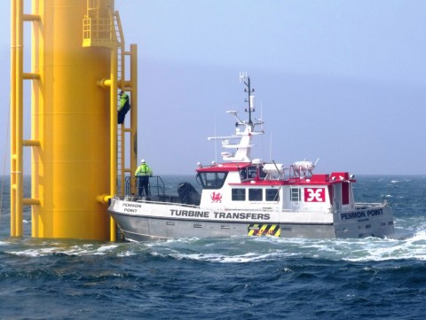  Figure 1 – Typical Transfer | 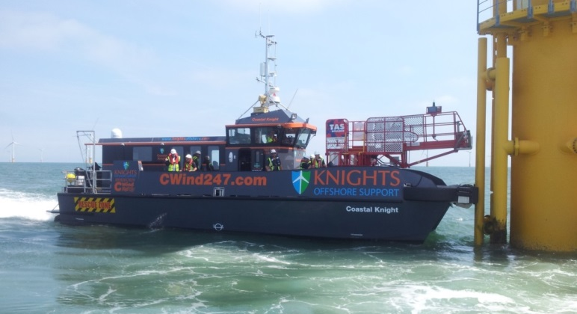  Fig.2 Heave Compensated Gangway

Fig.3 Transfer Brow on Swath

Fig.4 Foredeck Brow

Fig.5 Autobrow on a 20m Catamaran

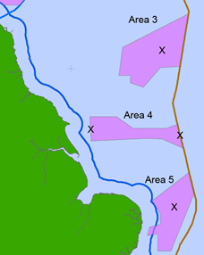  Data Extraction Points | 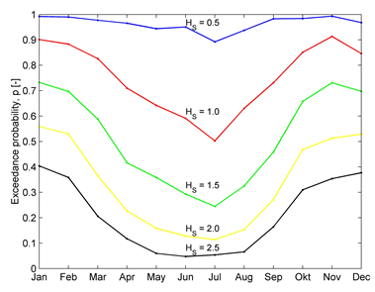  Hs at Location 3
Fig.6 North Sea Wave Data

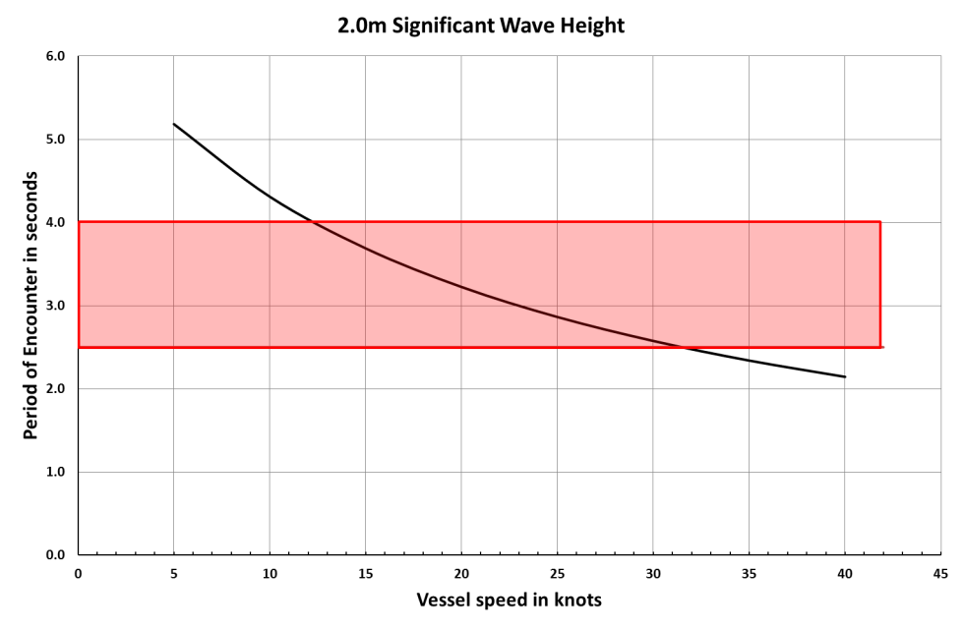
Fig.7 Periods of Encounter v Speed

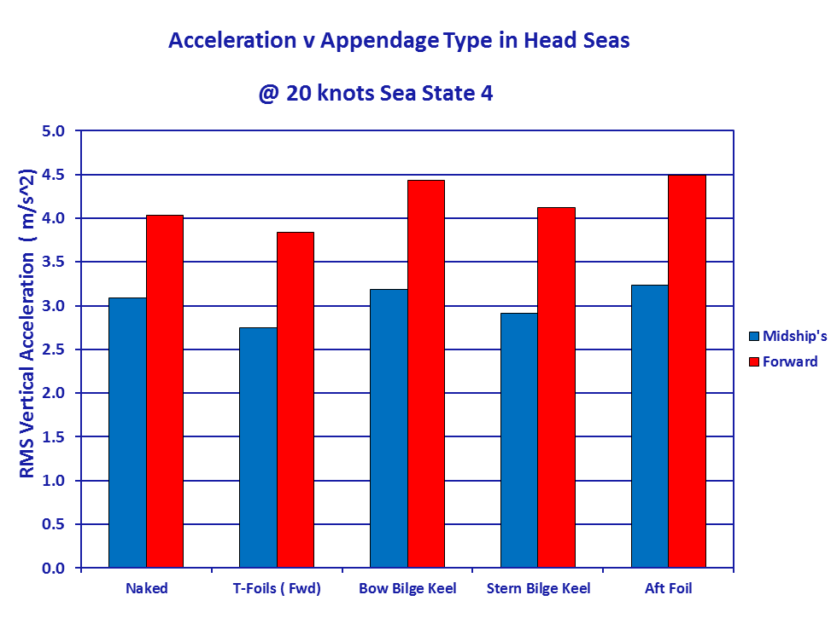
Fig.8 Effect of Appendages on Conventional Multihulls

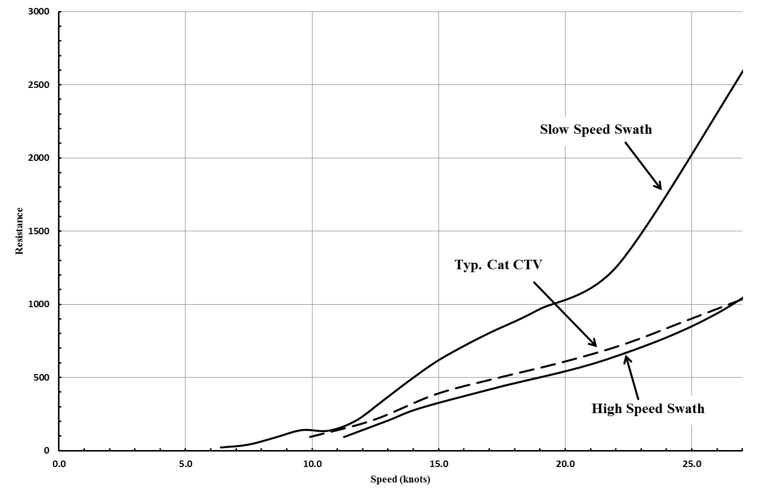
Fig.9 Resistance of Various Hull Form on an LWL of 23.8m

Fig.10 Arrangement of Motion control Sensors and Fin Assembly

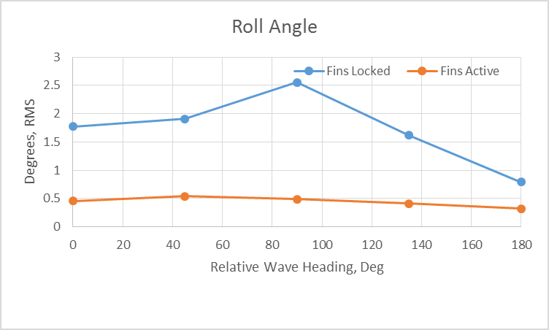  Roll Angles – Locked and Active Fins | 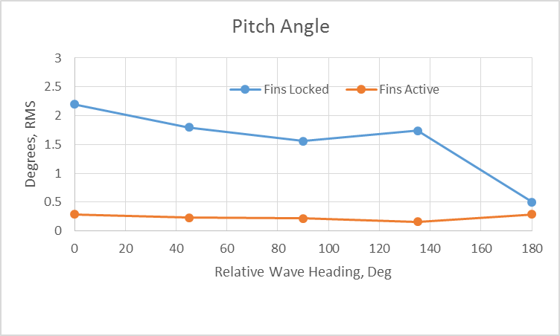  Pitch Angles – Locked and Active Fins
Fig.11 Roll and Pitch Angles of Fins

Fig.12 Fin Impulse Forces

ZS_{h} OFF | ZS_{h} ON
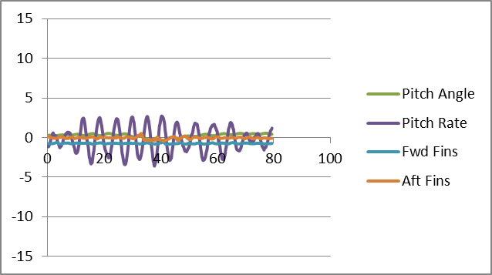 | 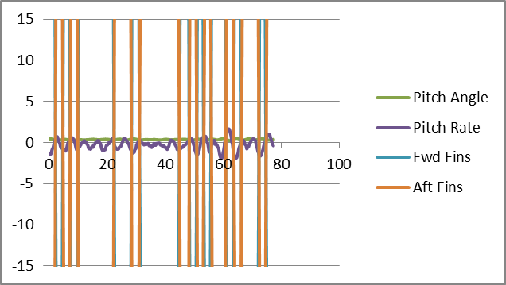
Fig.13 Effect of Zero-Speed Mode

